**Christopher King**

**2018141521058**

**Mechanical Design 2**

**Class Section 01**

**12/19/2021**

# **Problem 1**

Given: The teeth on a pair of mating gears have a 6 diametral pitch, 20° pressure angle AGMA involute form. The pinion has 19 teeth, and the gear has 37 teeth. Find the following parameters:

1. Gear ratio
2. Circular pitch
3. Base pitch
4. Pitch diameter of pinion and gear
5. Center distance
6. Addendum
7. Dedendum
8. Whole tooth depth
9. Clearance
10. Outside diameter of pinion and gear
11. Base diameter of pinion and gear
12. Contact ratio

**Solution:**

1. Gear ratio:
2. Circular pitch:
3. Base pitch:
4. Pitch diameter of pinion and gear: ,
5. Center distance:
6. Addendum:
7. Dedendum:
8. Whole tooth depth:
9. Clearance:
10. Outside diameter of pinion and gear: ,
11. Base diameter of pinion and gear: ,
12. Contact ratio:

# **Problem 2**

For a pair of spur gears with gear ratio of 4:1, specify the minimum number of teeth allowed on the pinion to avoid the problem of interference assuming full-depth tooth depth using

1. a 20° pressure angle, and
2. a 25° pressure angle.

**Solution:**

Using Eq. 13-11 with , , and ,

Rounding up,



Using Eq. 13-11 with , , and ,

Rounding up,

# **Problem 3**

Shaft a in the figure has a power input of 75 kW at a speed of 1000 rev/min in the counterclockwise direction. The gears have a module of 5 mm and a 20° pressure angle. Gear 3 is an idler.

1. Find the force F3b that gear 3 exerts against shaft b.
2. Find the torque T4c that gear 4 exerts on shaft c.

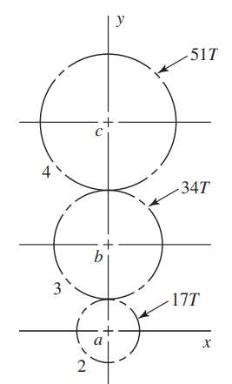

**Solution:**

which is in the positive -direction.



# **Problem 4**

For the countershaft shown below, Gear A receives power from another gear with the transmitted force FA applied at the 20° pressure angle as shown. The power is transmitted through the shaft and delivered through gear B through a transmitted force FB at the pressure angle shown.

Assume the gear ratio from gear B to its mating gear is 2 to 1.

1. Determine the minimum number of teeth that can be used on gear B without an interference problem in the teeth.
2. Using the number of teeth from part (a), what diametral pitch is required to also achieve the given 8-in pitch diameter?
3. Suppose the 20° pressure angle gears are exchanged for gears with 25° pressure angle, while maintaining the same pitch diameters and diametral pitch. Determine the new forces FA and FB if the same power is to be transmitted.

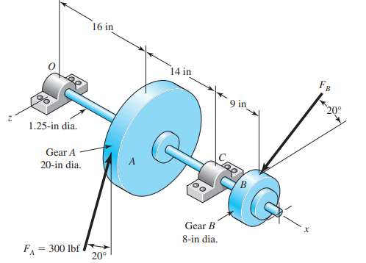

**Solution:**



Using Eq. 13-11 with , , and ,

Rounding up,



With

With

And